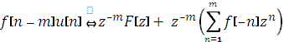
Z-transform right shift property:
Derivation: Consider an alternative expression for the unit step, :

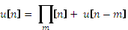

where 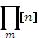 is a rectangular function with unit magnitude and width given by:

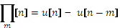

Using the above expression for the unit step, the z-transform property can be written as:

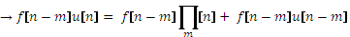

The rectangular function, is just a sum of time-shifted impulse functions:

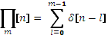

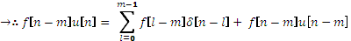

where the terms in the sum are the weights of the impulse function

Writing the expression by expanding the sum:

Taking the z-transform of both sides:

factor out from all the summed terms:

